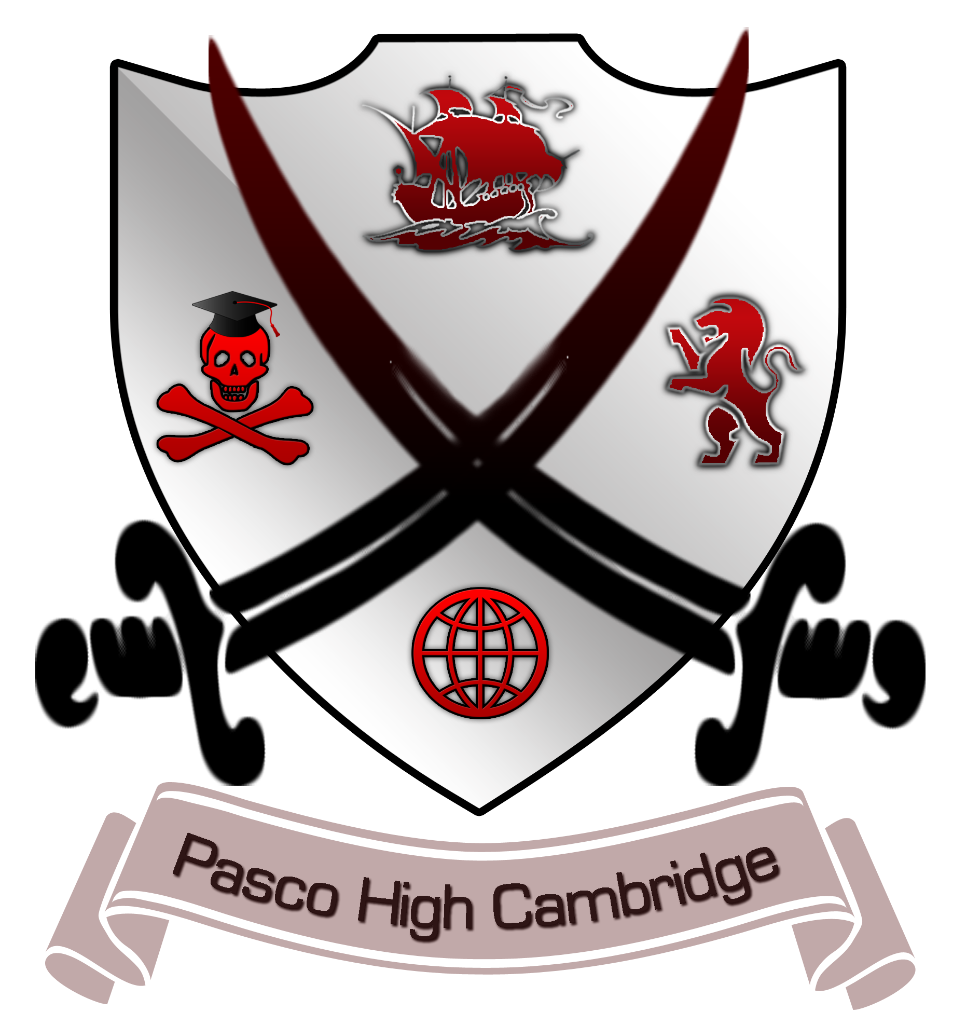
Pasco High School Cambridge Programme
Recommended Course Progression

9th Grade
English Pre-AICE English Language
Social Studies Pre-AICE World History
Science Pre-AICE Biology
Math Depends on which math the student is currently enrolled in. The progression is Algebra 1 Honors-> Pre-AICE Math 2/Geometry Honors->Pre-AICE Math 3->AICE Mathematics Probability & Statistics or Pre-Calculus Honors->AP Calculus
2 Electives

10th Grade
English Pre-AICE English Literature
Social Studies AICE U.S. History or U.S. History Honors
Science Pre-AICE Chemistry
Math Depends on which math the student is currently enrolled in. The progression is Algebra 1 Honors-> Pre-AICE Math 2/Geometry Honors->Pre-AICE Math 3/Algebra 2 Honors->AICE Mathematics Probability & Statistics or Pre-Calculus Honors->AP Calculus
2 Electives

11th Grade
English AICE English Language
Social Studies Elective AICE Global Perspectives
Science AICE Chemistry, AICE Biology, AICE Environmental Management
Math Depends on which math the student is currently enrolled in. The progression is Algebra 1 Honors-> Pre-AICE Math 2/Geometry Honors->Pre-AICE Math 3/Algebra 2 Honors->AICE Mathematics Probability & Statistics or Pre-Calculus Honors->AP Calculus
2 Electives

12th Grade:
English AICE English Literature
Social Studies Only 3 credits required – if already met may choose elective or elect to take another social studies course.
Science Only three credits required- if already met may choose an elective or elect to take another science course.
Math Depends on which math the student is currently enrolled in. The progression is Algebra 1 Honors-> Pre-AICE Math 2/Geometry Honors->Pre-AICE Math 3/Algebra 2 Honors->AICE Mathematics Probability & Statistics or Pre-Calculus Honors->AP Calculus
2 Electives

