Pasco High School

Community Service Proposal Form and Log

Name:________________________________________ Student #:___________________ Grade level:________

1. Through what agency do you intend to perform your community service hours?
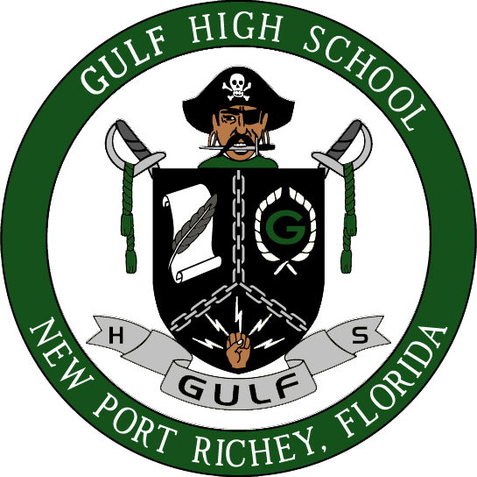

2. Identify one or several social problems or concerns you wish to address through community service?
For example:
  - Serving my community in an area where I can assist children (or adults or the elderly)
  - My plan is to help specials needs students in the area of sports (or other extracurricular activity: dance, art, etc.)
  - The environment is a special concern of mine

3. What is your plan for addressing the problem(s) listed in question #2

_____________________________________________ _______________
Student Signature Date

Keep copies of all documentation for your records.
I understand that this proposal to participate in community service is entirely voluntary on my part and that the completion of documented community service related to this proposal can be used to satisfy the community service requirement of the Florida Academic Scholarship, Florida Medallion Scholarship and Gold Seal Vocational Scholars Award. Selection of the organization, services performed, and documentation are the responsibility of the student. Signature of the Community Service Contact indicates that the student has presented an appropriate social issue for meeting the community service requirement of the Bright Futures Scholarship Program.

Do not write below line. To be completed by Career Specialist

______ APPROVED (If approved, you may begin your community service. Do not forget to complete the community Service log on the back)

_____ DENIED (If denied, please submit a new proposal for a different community service. If you have questions, please come speak to the Career Specialist)

___________________________________________ ____________
Career Specialist Signature Date

LOG ON BACK ➔

Pasco High School
Community Service Log
Name:________________________________________ Student #:___________________ Grade level:________

The student must submit a proposal to the Community Service Contact at the school site before beginning any project.
It is the responsibility of the student to keep the actual record of the hours of Community Service performed. Log record must be turned in to the Career Specialist.

Name of Organization:_______________________________________________________________________________

CONTACT PERSON:_____________________________________________ TELEPHONE:______________________
(PLEASE PRINT)

DATE OF ACTIVITY | HOURS LOGGED | SIGNATURE OF CONTACT PERSON

TOTAL HOURS___________

REFLECTION:

I agree that I have performed the above hours.

____________________________________ ______________
Student Signature Date

____________________________________ ______________
School Career Specialist Date

NOTE: Keep copies for your records of all documentation. Community service hours will reflect on high school transcript.

