Online Dual Enrollment Request Form – Student
- Prior to starting the Dual Enrollment Request Form the following steps must be completed:
  - Submit an Online Dual Enrollment Admissions Application (only new students/readmissions).
    - https://cpnta.phsc.edu/dualapp/English/WDEAI.aspx
  - Log into WISE to obtain your myPHSC username and ID number for your default password (only if you have not already changed your myPHSC password).
    - https://cpnta.phsc.edu/csrs/English/WEBON.aspx
  - Go to the Self Service Password Reset system (SSPR) to change your myPHSC password (only if you have not already changed your myPHSC password).
    - https://mysspr.phsc.edu/sspr/private/Login
- Begin the Dynamic Forms process.
  - Click on link: https://qafederation.ngwebsolutions.com/idp/startSSO.ping?PartnerSpId=PHSC2ldap&TargetResource=https%3A%2F%2Fdynamicforms.ngwebsolutions.com%2FShowForm.aspx%3FRequestedDynamicFormTemplate%3Dcb26b2da-941e-422c-9e2f-dbe28c04475a
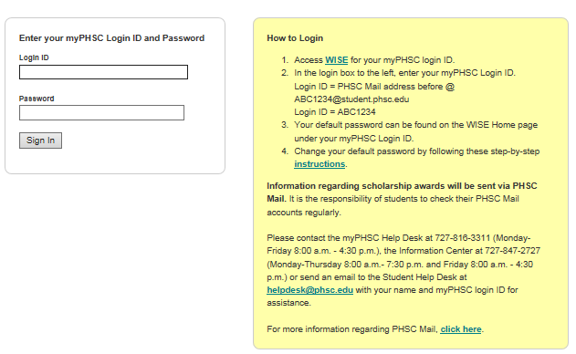
  - Log in with your myPHSC username and password

  - Click on “Complete this Form”
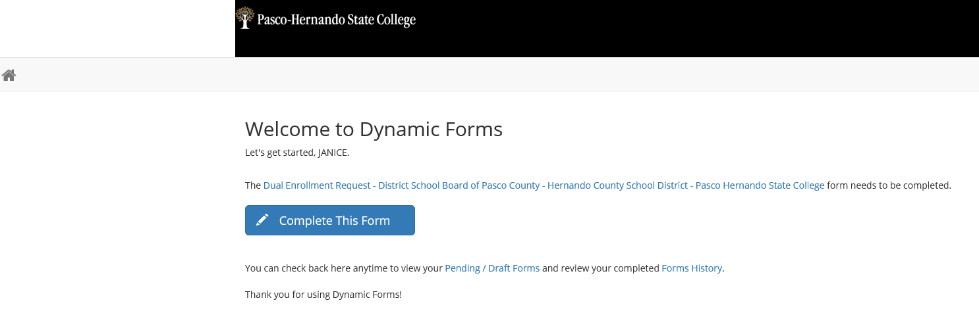

  - Enter your parent/guardian’s name and email address.

  - Select your High School Counselor and PHSC Academic Advisor.

  - Click Continue.
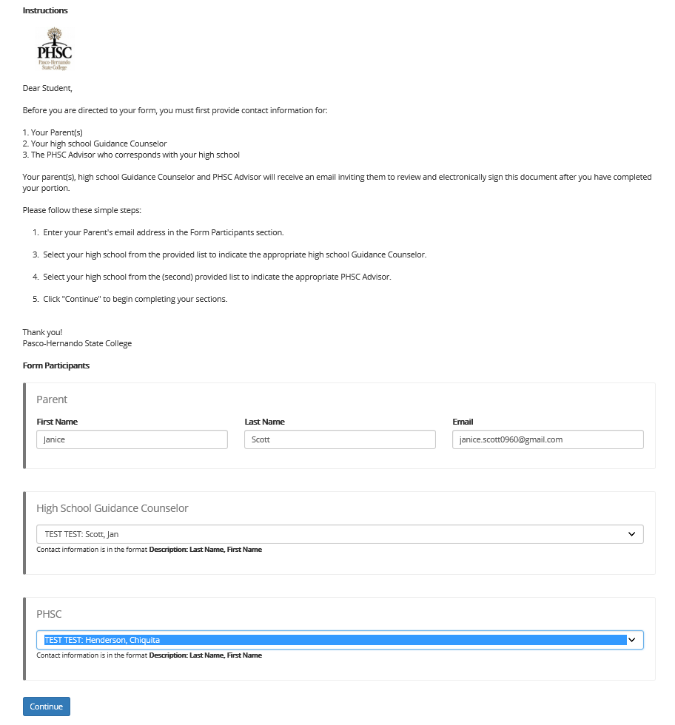

  - Enter your District Student Number, Grade, High School County, High School, Anticipated Graduation Date and Intended Major on the Dual Enrollment Request Form. Note: You must type in your intended major for the university / college you plan to attend after high school graduation.

  - Please read the Terms and Conditions, select “accept “and click “Next”.
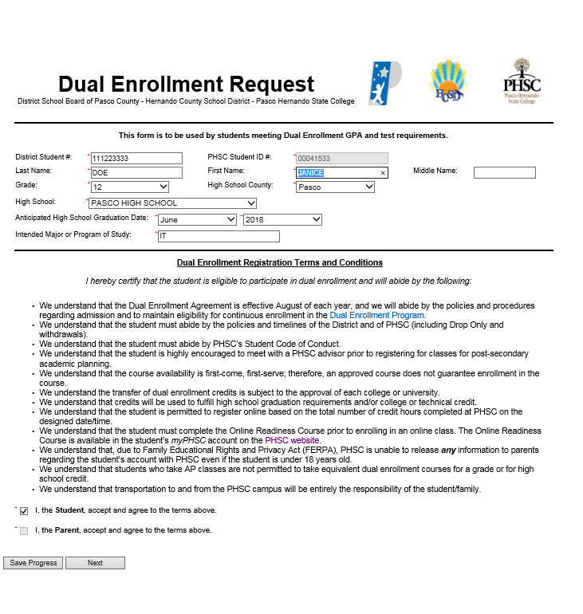

  - Click “Next”. This page is for high school use only.
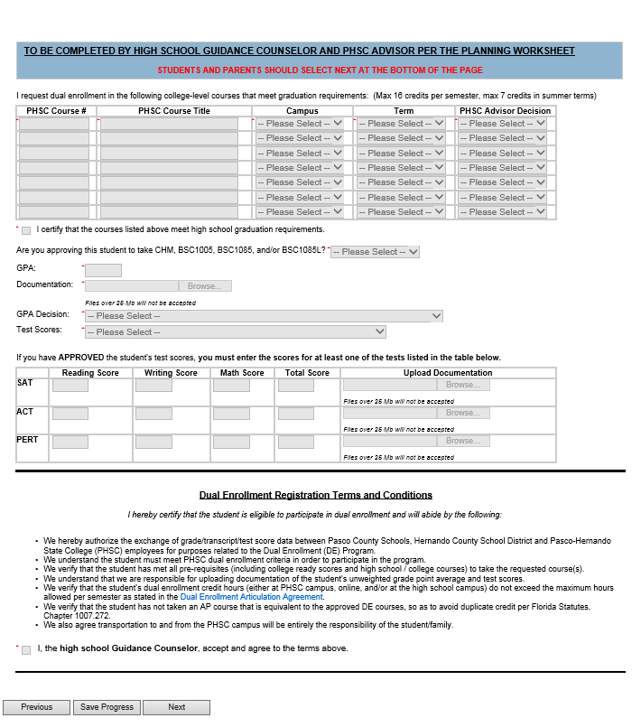

  - Click “Next”. This page is for PHSC use only.
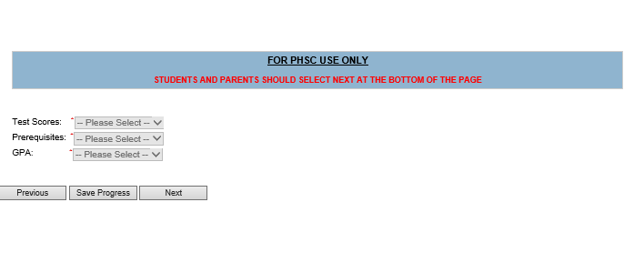
  - Submit your electronic signature. 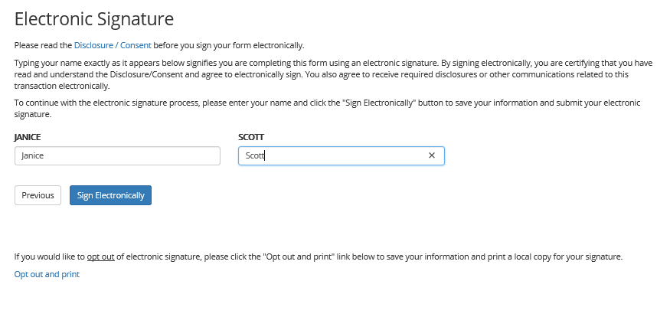
Note: The student will receive an email confirmation that the Dual Enrollment Request Form has been submitted for processing.

Note: The student’s parent/guardian will receive an email notification with instructions to complete the Dual Enrollment Terms and Conditions.

You can also select View Form PDF.
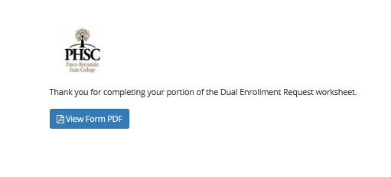
Note: Email confirmations will be sent to your PHSC email only.
Note: Students should review the “How to Register for Classes Using WISE” YouTube Video.
https://www.youtube.com/watch?v=8lyMsmT2B1g

