Ms. Graham
cgraham@pasco.k12.fl.us
Pre-AICE English Language
Summer Reading Assignment: The Memoir
Memoir Selection
Select ONE memoir for your summer reading. A memoir, by definition, covers a specific period of time or experience within a person’s life. It is non-fiction and gives a glance into the life and experiences of another real person. You may select any memoir that you have not previously read. I will include some examples below but please do not limit your selection to this list. If you’re concerned you can email me your selection for approval. If you can purchase/find your own copy, you will be able to do annotations in the margins. Otherwise, you will need sticky notes for your annotations. If you don’t want to buy a book be sure to check the public library.

These are only EXAMPLES, feel free to research and find a memoir that most appeals to you that you will enjoy reading!!!

I am Malala by Malala Yousafzai
This Star Won’t Go Out by Ester Earl
Laughing at My Nightmare by Shane Burcaw
The Glass Castle by Jeanette Walls
Soul Surfer by Bethany Hamilton
No Summit out of Sight by Jordan Romero

Night by Elie Weisel
The Boy on the Wooden Box by Leon Leyson
The Diary of a Young Girl by Anne Frank
Funny in Farsi by Faroozeh Dumas
Maus by Art Spiegelman
A Long Way Home by Ishmael Beah

Assignment Parts
These assignments will be due the first week of class! Come prepared to discuss your memoir.
1. READ your book carefully.
2. Annotations--Annotate your book – good notes tend to enhance comprehension and retention of ideas. Your annotations should be handwritten (either in the book or on sticky notes in the book or on separate paper). See attached sheet for more specific details on annotations.
3. Rhetorical Triangle Worksheet—The Rhetorical Triangle is a tool used to help you understand and analyze writing. It looks at 3 critical components and how they interact. Complete the worksheet by filling in statements as indicated.
4. Quote Response Paragraphs--Type quote response assignments. Please double space and use Times New Roman, 12 point font. See below for more specific details on responses.

Annotating a text: A few thoughts and tips
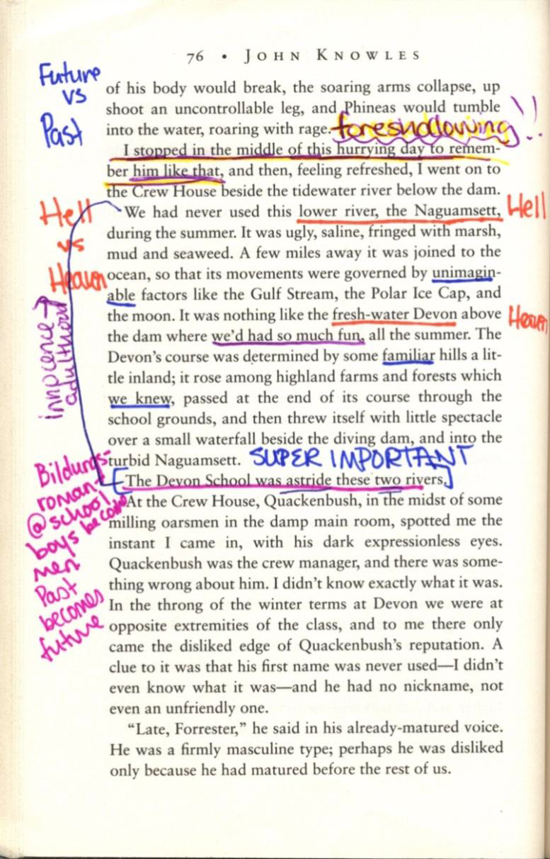
1.DON’T make it harder than it is!
2.Do mark things that stand out to you
even if you are not sure why they do (you will
figure that out eventually)
3.Do read actively and think about what you
should look for BEFORE you begin to read
and while you read. Ask yourself questions
like: what does this writer want me to think
about? Does he want me to learn something?
Does he want me to understand his point of view?
Does he just want to tell a good story? etc.
4. Do pay attention to titles, special formatting, chapter breaks/endings/beginnings consider making brief notes
at the end of each chapter.
5.Do pay attention to language. Writers use
words like painters use brushstrokes, color,
and line to create a memorable picture in
your mind. Note passages that are
particularly interesting to you in terms of the language.
6.Don’t worry about writing something wrong
or silly. There is no such thing when you are
annotating a long text.
7.Do use different colors purposefully. It can
be fun to highlight colors assigned to
specific types of notes pink for plot notes,
green for language, blue for random ideas.
8. Don’t wait to read and annotate the book the
last weekend before school starts. If you
have to rush, you won’t have time to read
carefully and you won’t remember much of value.

3. Rhetorical Triangle Worksheet
SPEAKER: As you read, be on the look out for details that help to develop the Speaker, in this case the central figure of the memoir, or the author. List those details about the Speaker here pulling quotes that tell us about the author.

#1 ____________________________________________________________________________________________________________________________________________________________________

#2 ____________________________________________________________________________________________________________________________________________________________________

#3 ____________________________________________________________________________________________________________________________________________________________________

#4 _____________________________________________________________________________________________________________________________________________________________________

#5 _____________________________________________________________________________________________________________________________________________________________________

#6 _____________________________________________________________________________________________________________________________________________________________________

#7 _____________________________________________________________________________________________________________________________________________________________________

#8 _____________________________________________________________________________________________________________________________________________________________________

#9 _____________________________________________________________________________________________________________________________________________________________________

#10 _____________________________________________________________________________________________________________________________________________________________________

#11 _____________________________________________________________________________________________________________________________________________________________________

#12 ______________________________________________________________________________________________________________________________________________________________________

#13 ______________________________________________________________________________________________________________________________________________________________________

#14 ________________________________________________________________________________________________________________________________________________________________________

#15 ________________________________________________________________________________________________________________________________________________________________________

#16 _________________________________________________________________________________________________________________________________________________________________________

#17 __________________________________________________________________________________________________________________________________________________________________________

#18 __________________________________________________________________________________________________________________________________________________________________________

#19 ___________________________________________________________________________________________________________________________________________________________________________

#20___________________________________________________________________________________________________________________________________________________________________________

AUDIENCE: As you read, think about the intended audience for this memoir. Who exactly does the Speaker hope to reach? Did he/she write primarily to satisfy him or herself? —to explain to a particular group how/why decisions were made? —for a more general audience, possibly of a particularly age or generation? —primarily to men or women, or both? —to people who basically agree with him/her, or to convince those who do not? Write your ideas on Audience here, include passages that seem to exemplify who the intended audience is and why.
#1 ____________________________________________________________________________________________________________________________________________________________________

#2 ____________________________________________________________________________________________________________________________________________________________________

#3 ____________________________________________________________________________________________________________________________________________________________________

#4 _____________________________________________________________________________________________________________________________________________________________________

#5 _____________________________________________________________________________________________________________________________________________________________________

#6 _____________________________________________________________________________________________________________________________________________________________________

#7 _____________________________________________________________________________________________________________________________________________________________________

#8 _____________________________________________________________________________________________________________________________________________________________________

#9 _____________________________________________________________________________________________________________________________________________________________________

#10 _____________________________________________________________________________________________________________________________________________________________________

MESSAGE: Every communication has a message. Sometimes we call it the theme, or the main idea. Often we find more than one. As you read, try to identify at least five Messages of this memoir, and list those as statements here.
#1 ____________________________________________________________________________________________________________________________________________________________________

#2 ____________________________________________________________________________________________________________________________________________________________________

#3 ____________________________________________________________________________________________________________________________________________________________________

#4 _____________________________________________________________________________________________________________________________________________________________________

#5 _____________________________________________________________________________________________________________________________________________________________________

USE OF LANGUAGE: As you read, think about how the author uses language. Try to identify figurative language used (personification, symbol, metaphor, simile,hyperbole ) and think about what each instance adds to the text. Think about particular word choices that seem particularly effective. Write examples of figurative language and/or striking diction here.
#1 ____________________________________________________________________________________________________________________________________________________________________

#2 ____________________________________________________________________________________________________________________________________________________________________

#3 ____________________________________________________________________________________________________________________________________________________________________

#4 _____________________________________________________________________________________________________________________________________________________________________

#5 _____________________________________________________________________________________________________________________________________________________________________

#6 _____________________________________________________________________________________________________________________________________________________________________

#7 _____________________________________________________________________________________________________________________________________________________________________

#8 _____________________________________________________________________________________________________________________________________________________________________

#9 _____________________________________________________________________________________________________________________________________________________________________

#10 _____________________________________________________________________________________________________________________________________________________________________

#11 _____________________________________________________________________________________________________________________________________________________________________

#12 ______________________________________________________________________________________________________________________________________________________________________

#13 ______________________________________________________________________________________________________________________________________________________________________

#14 ________________________________________________________________________________________________________________________________________________________________________

#15 ________________________________________________________________________________________________________________________________________________________________________

#16 _________________________________________________________________________________________________________________________________________________________________________

#17 __________________________________________________________________________________________________________________________________________________________________________

#18 __________________________________________________________________________________________________________________________________________________________________________

#19 ___________________________________________________________________________________________________________________________________________________________________________

#20___________________________________________________________________________________________________________________________________________________________________________

Pre-AICE Language Summer Reading Assignment: Memoir Quote Response Paragraphs
• _Choose two important/interesting quotes from the memoir, roughly one from the first half, and the other from the second half. Look for critical passages that convey the essence of the text or the author/central character.
• _You may use the following questions to help select passages and generate ideas.
▪ Why does the passage impress, intrigue, horrify, or puzzle you?
▪ Do you find the author’s use of language appealing or powerful? Does the passage jump off the page as great description?
▪ Does the passage prompt a strong response from you as you read it? Does it present itself as so well-crafted that you just love the sound of it? Is the language beautiful, descriptive, graphic?
▪ Is the passage particularly meaningful, to you and your feelings and emotions, or to the author/central character?
▪ Do you find yourself in agreement/disagreement with the ideas expressed?
▪ Does the passage remind you of a situation you have lived as well?
▪ Does the passage make you laugh out loud? Melancholy? Something else?
▪ Does the author raise intriguing questions or issues?
▪ Does the passage challenge or expand your thinking?
▪ Does the passage provide particular insight into the development of the author/central figure?
▪ Does the passage reflect the specifics of the time and/or place of the narrative?
• _Write a well developed paragraph that discusses the importance of each passage to the memoir and explains why you selected it.
• _Paragraphs should be at least 11 sentences long, should include specific details and/or quotes, and should be organized around a central idea.
The Process
➢ Prewriting—choose quote & jot ideas
➢ Write a draft of each paragraph
➢ Revise carefully—remember this is the first writing I will see from you. Wow me!! Use carefully chosen diction, make sure your sentences sound smooth, check your logic and organization! AND, proofread!
➢ Type your final copy with the passage at the top: double spaced, in Times New Roman, 12 point font.

