AICE DIPLOMA
Tracking Sheet

Course | Group | Year Taken | Exam Sore
1. AS Global Perspectives | CORE
2. | GROUP 1: Mathematics & Science
3. | GROUP 2: Languages
4. | GROUP 3: Arts & Humanities
5.
6.
7.

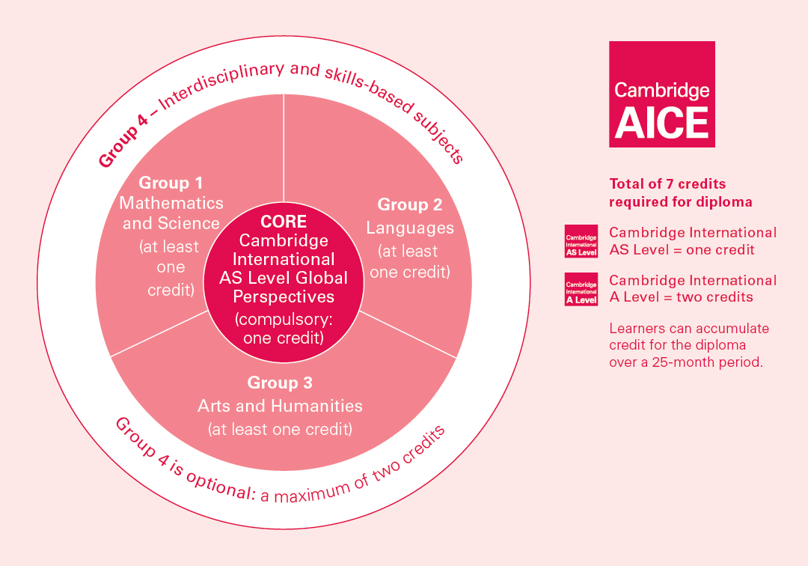

Group 2: Languages
AS English Language
AS Spanish Language

Group 3: Arts & Humanities
AS & AL Art & Design
AS Business Studies
AS English Literature
AS Geography
AS U.S. History
AS Psychology

Group 4: Interdisciplinary & Skills Based Subjects (optional)
AS Thinking Skills

Core: Global Perspectives
Global Perspectives & Research (AS Level one credit only)

Group 1: Mathematics & Science
AS Biology
AS Chemistry
AS Design & Technology
AS Environmental Management
AS Mathematics Probability & Statistics
AS Psychology

