Online Dual Enrollment Request Form – Parent/Guardian
- The parent/guardian will receive an email with a link to complete their part of the Dual Enrollment Request Form. Click on the link provided in the email.
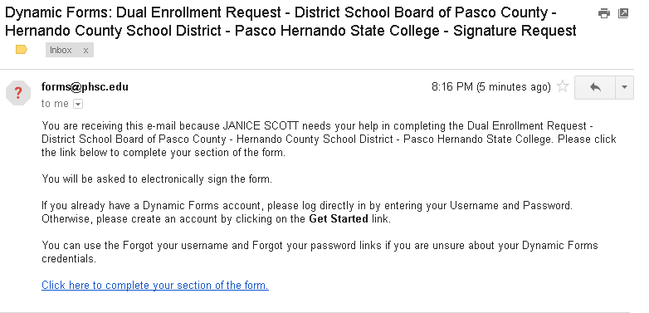
- The parent/guardian will then be presented the login page for Dynamic Forms. If the parent/guardian does not already have an account, an account needs to be created by clicking on the “Create New Account” button. If the parent/guardian already has an account, skip to Step 5 and use the username and password previously created.
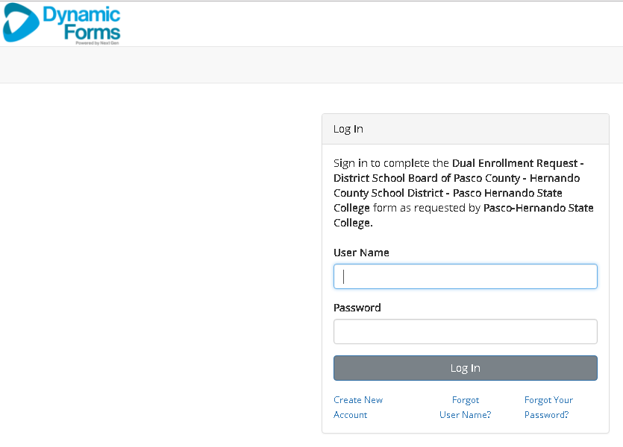
- Fill out the “create new account” page.
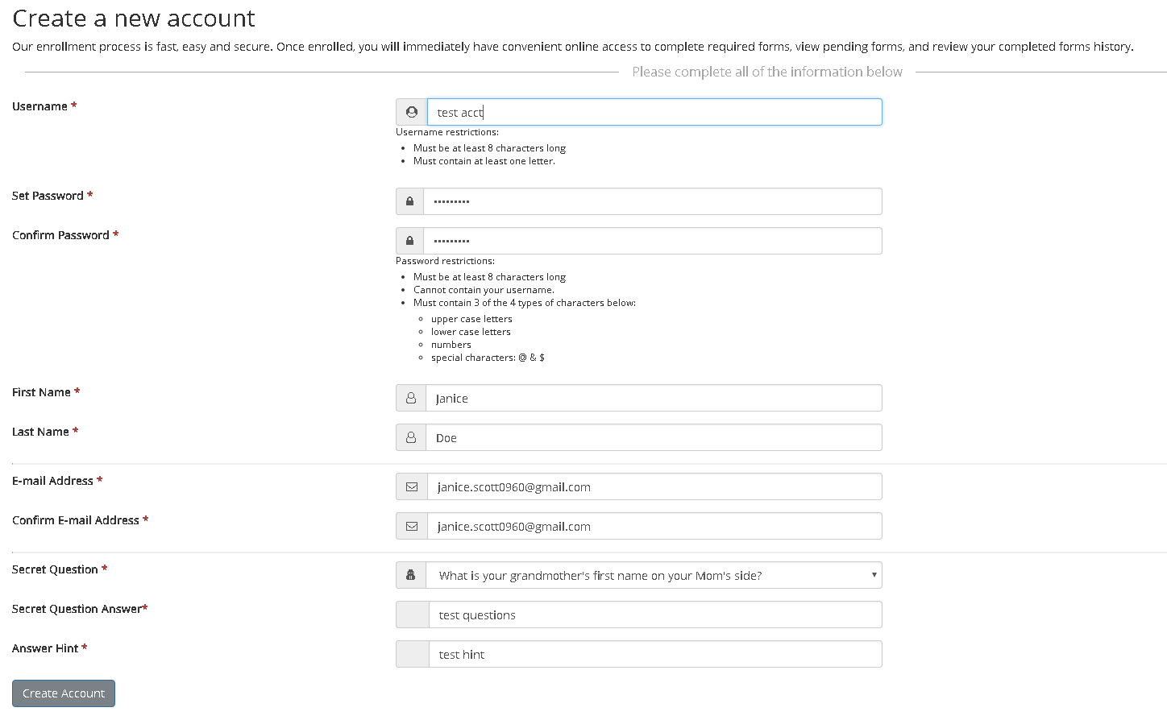
- Click on “create account”. An email will be sent to the parent/guardian to verify their account.
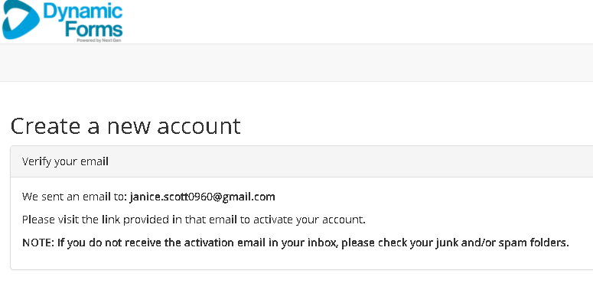
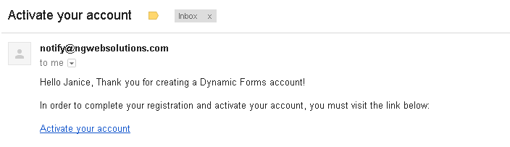

- The parent/guardian will enter their username and password. Note: Passwords are case sensitive.
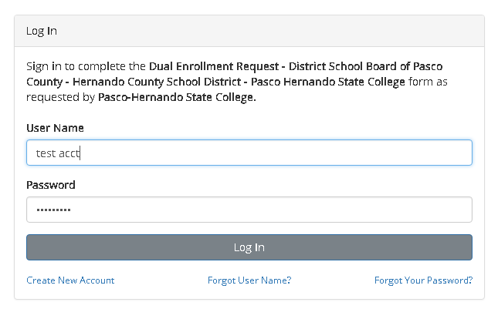
- The parent/guardian will need to confirm their identity by answering their security question. (This will happen if you are a new user or a returning user that did not click on “This is my device”). Click Login.
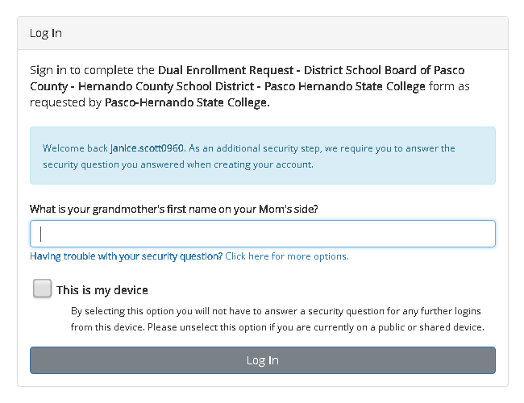

- The parent/guardian is now logged in and can complete their part of the Dual Enrollment Request form.
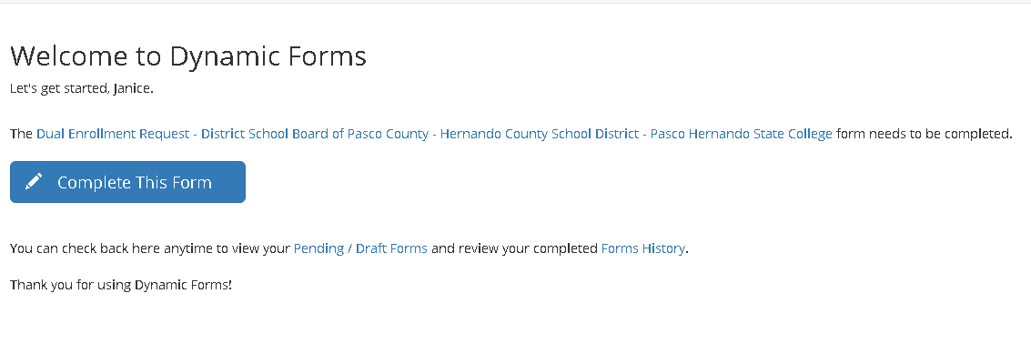
- Please read the terms and conditions of the Dual Enrollment Registration Terms and Conditions. Click on “Accept and Agree.” From here, you can either “reject” your student’s application or you can click “next” to approve.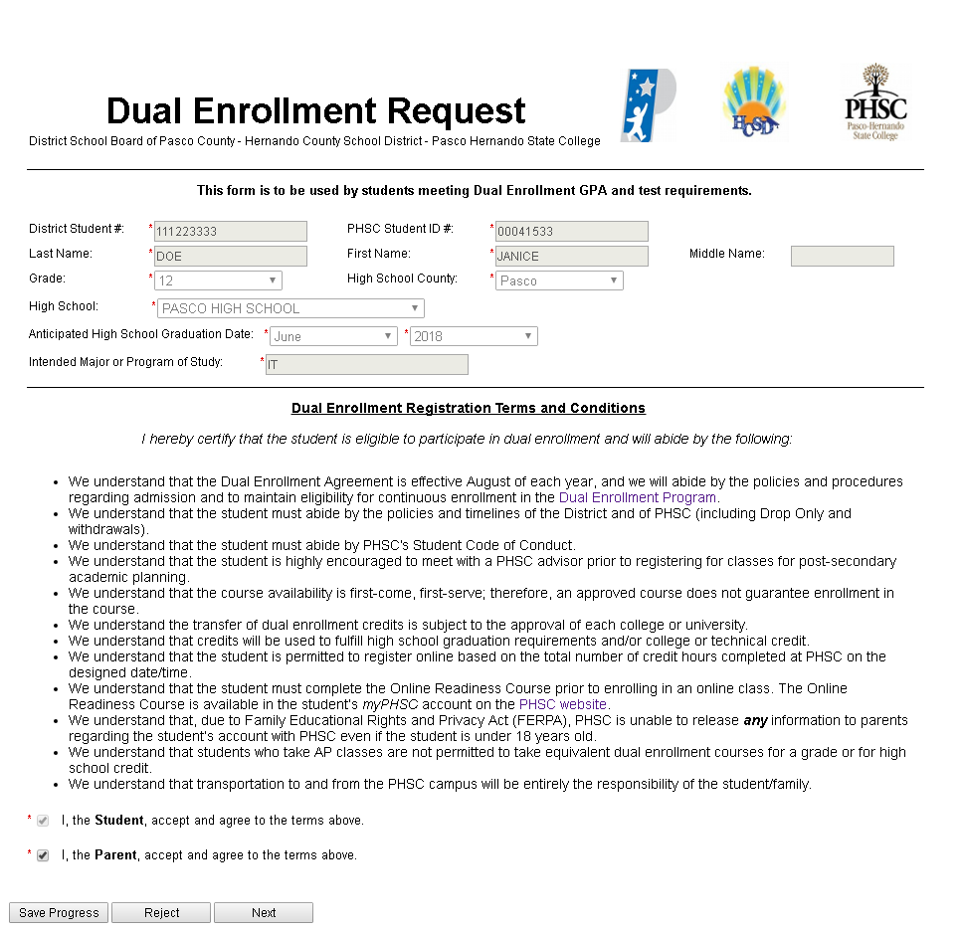
- Click “Next.” This page is for high school use only.
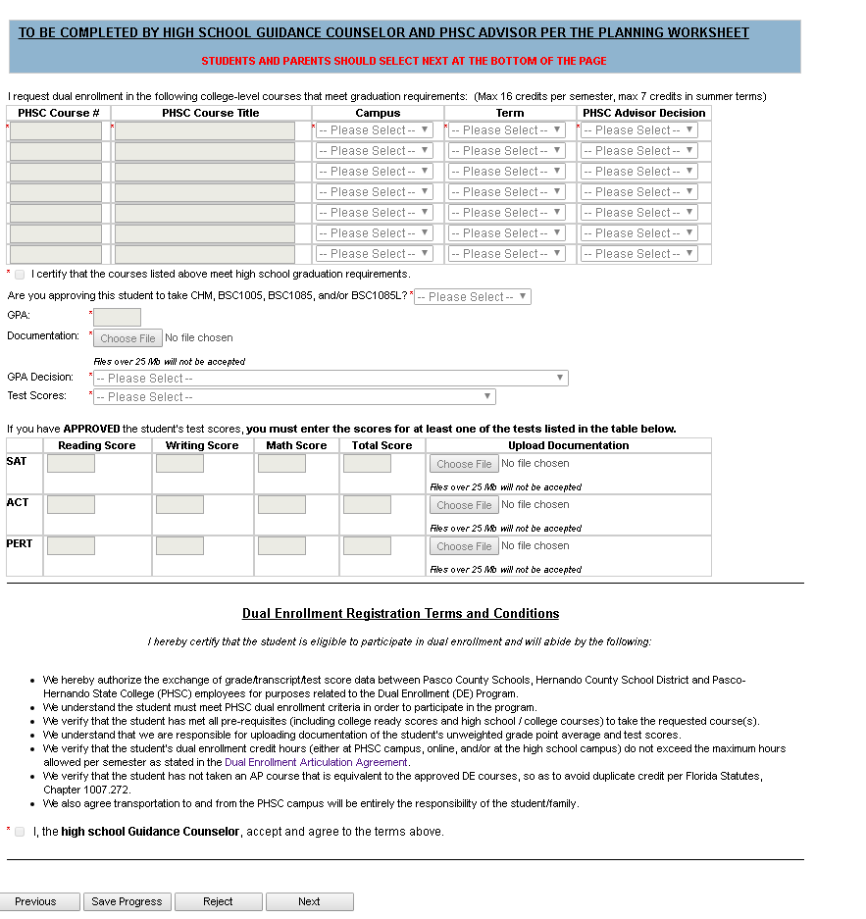

- Click “Next”. This page is for PHSC use only.
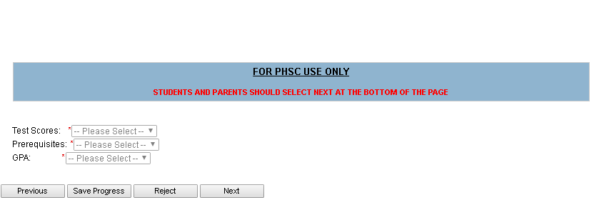
- Submit your Electronic Signature.
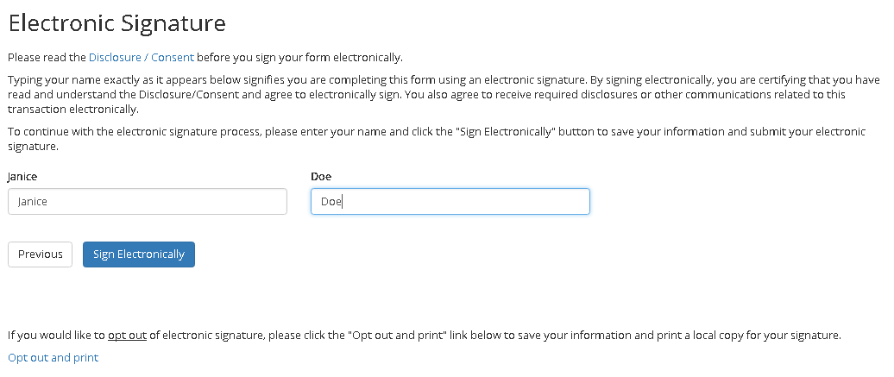
- Once the parent/guardian electronically signs the form, the school counselor will receive an email so that they can process the form with the courses and provide the necessary documentation. You can also select View Form PDF.
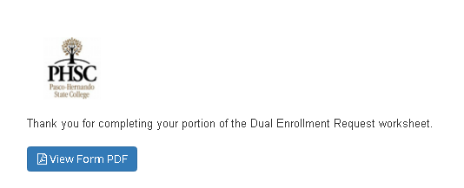
- Please check your email account for confirmation emails.

